CS 255 System Design Document Template

UML Diagrams

UML Use Case Diagram
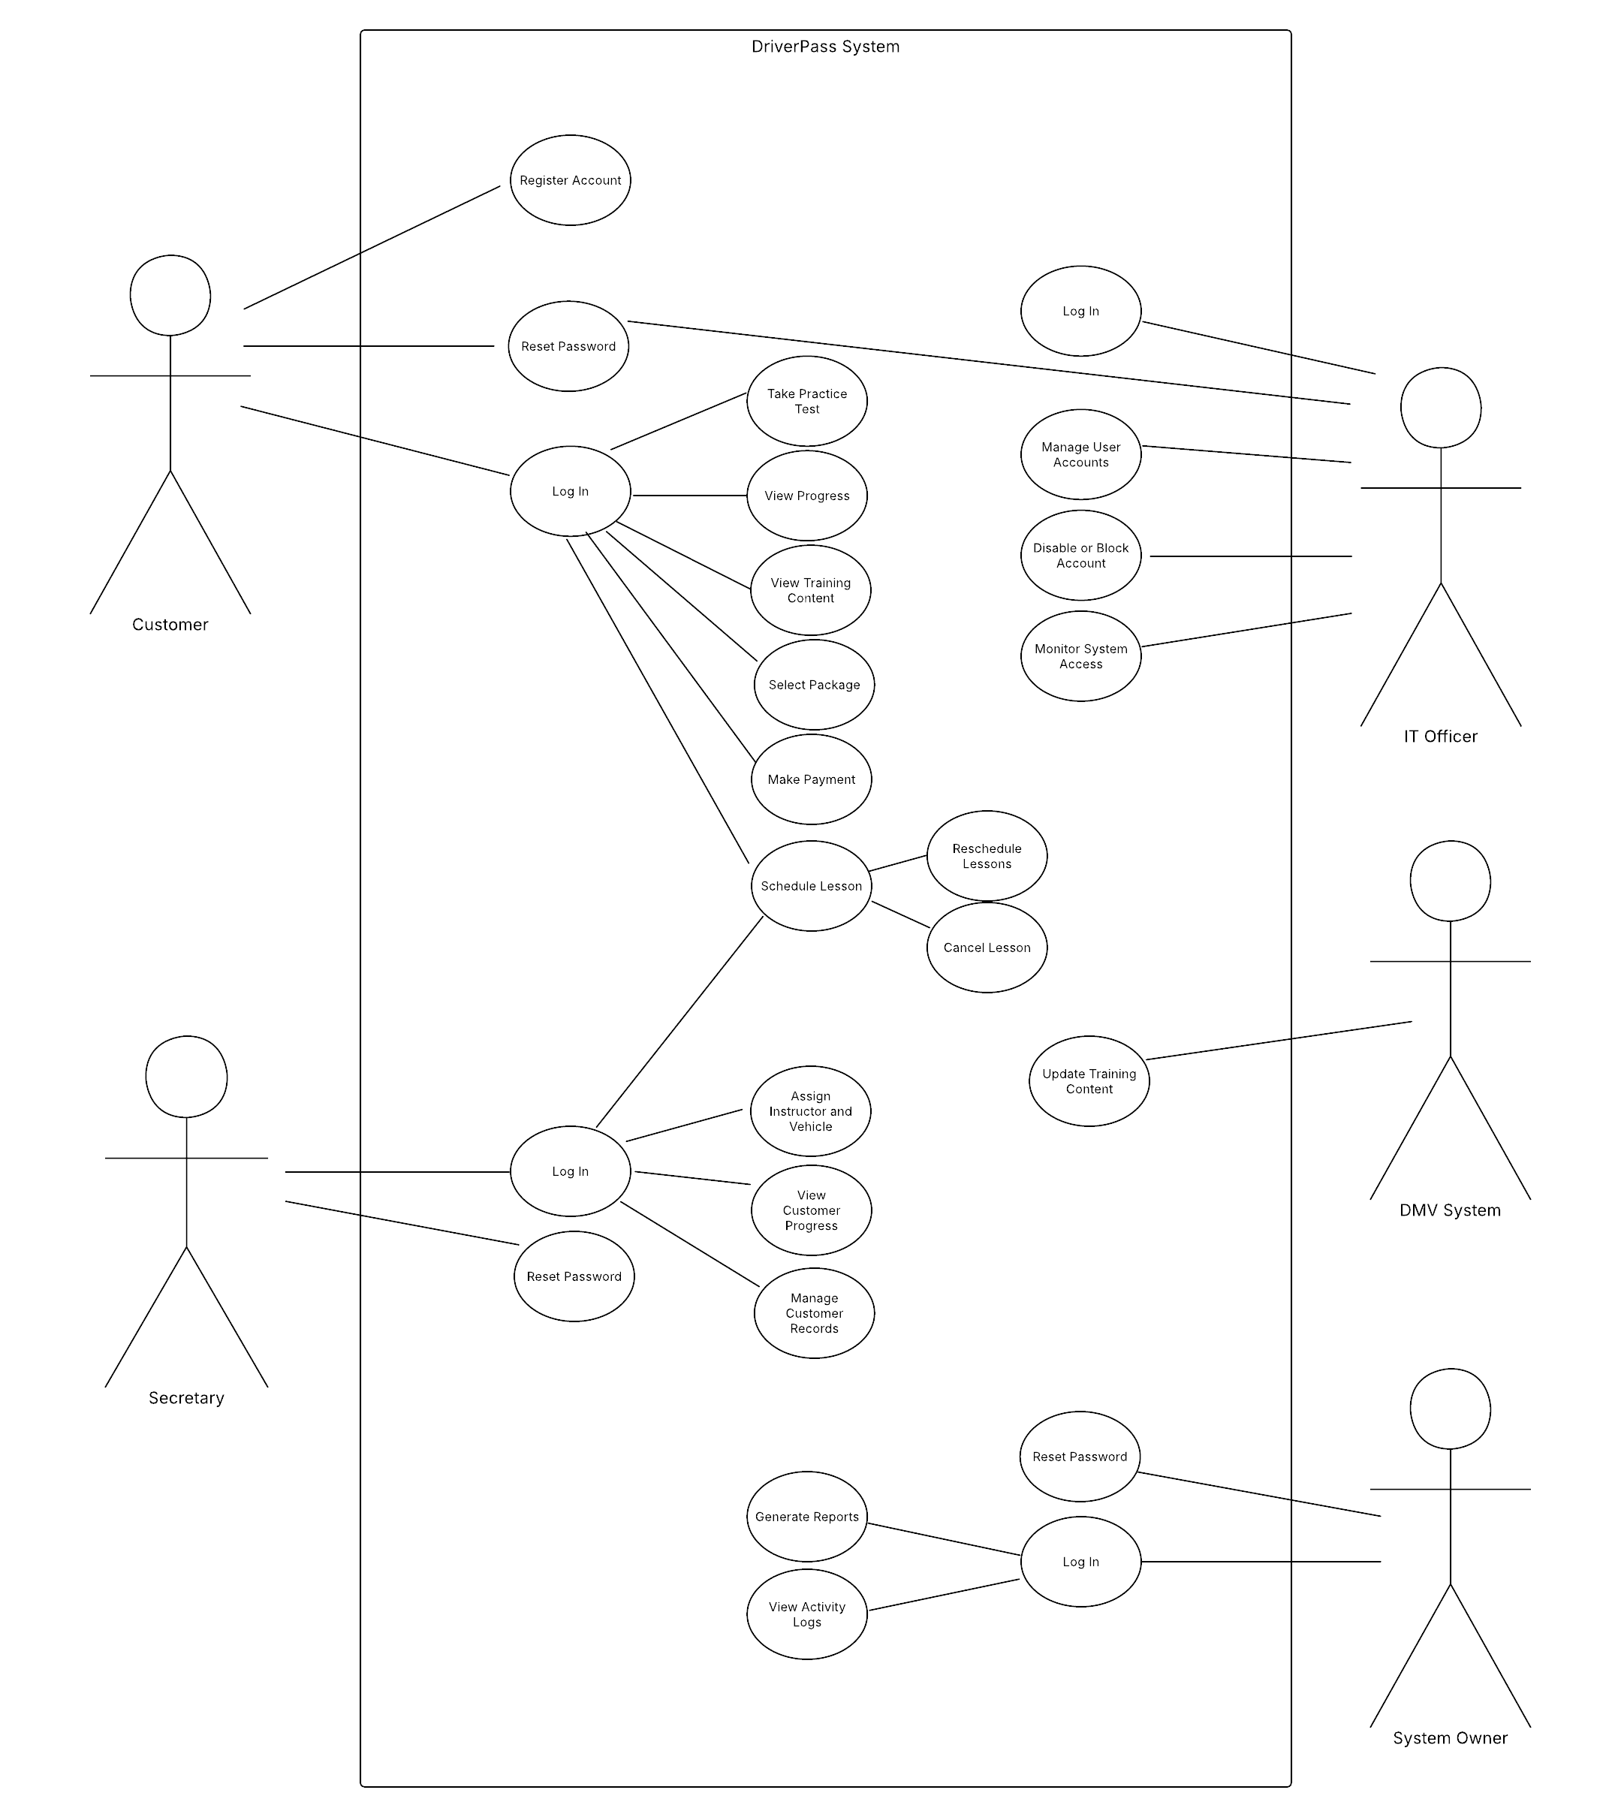

UML Activity Diagrams
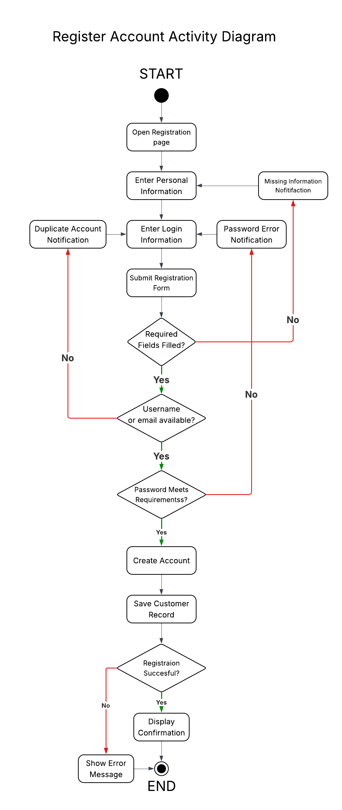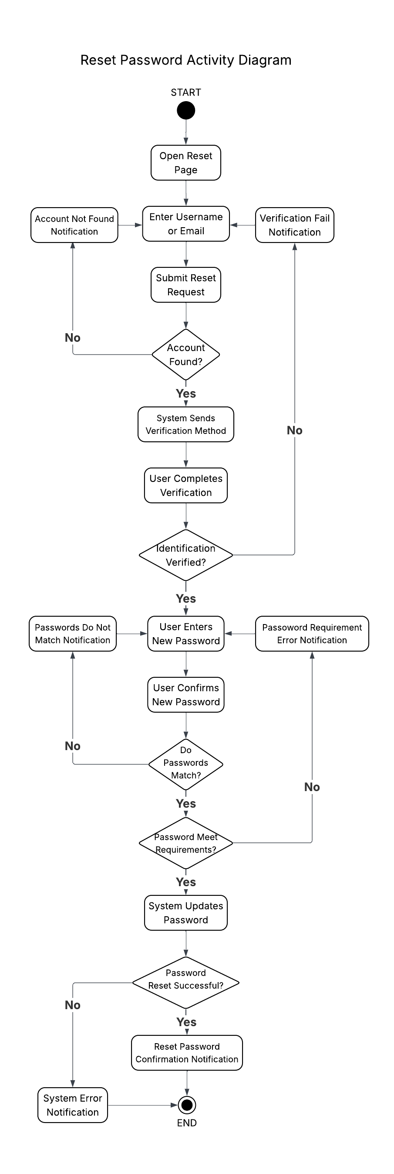

UML Sequence Diagram
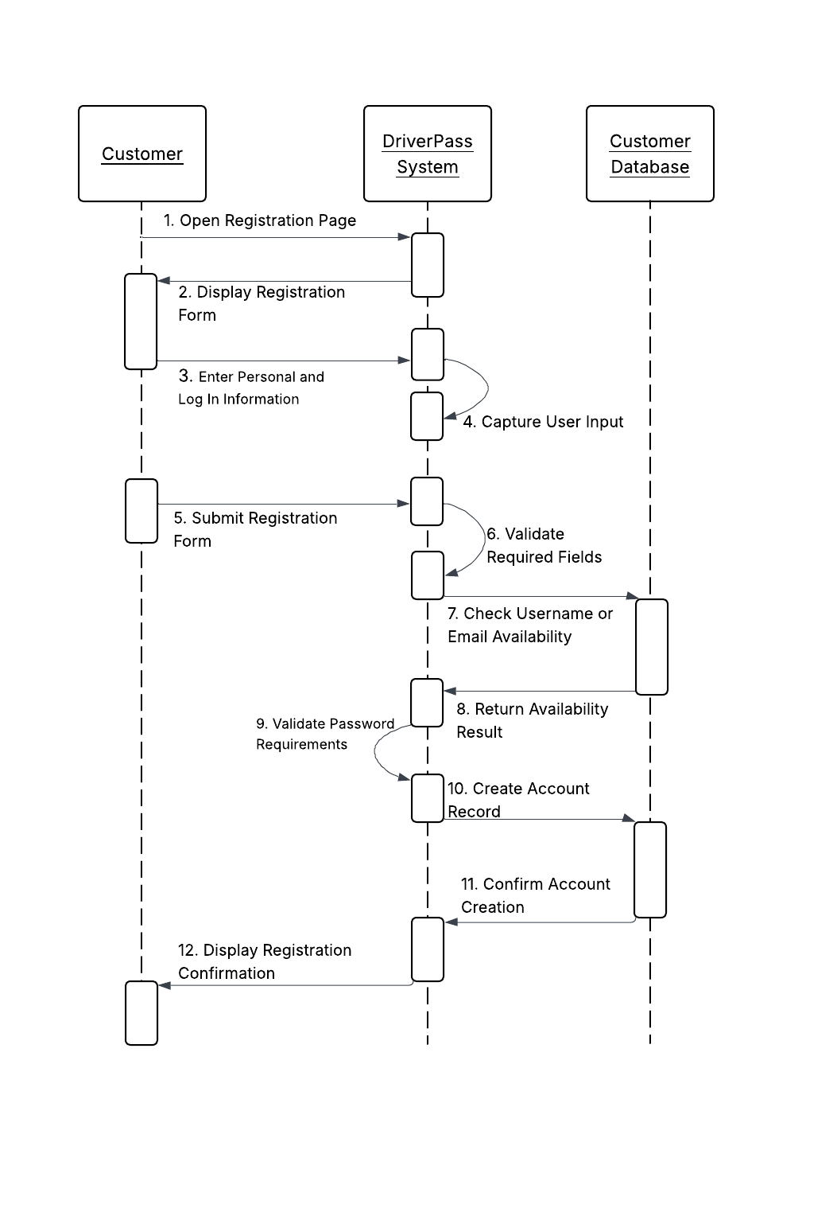
UML Class Diagram
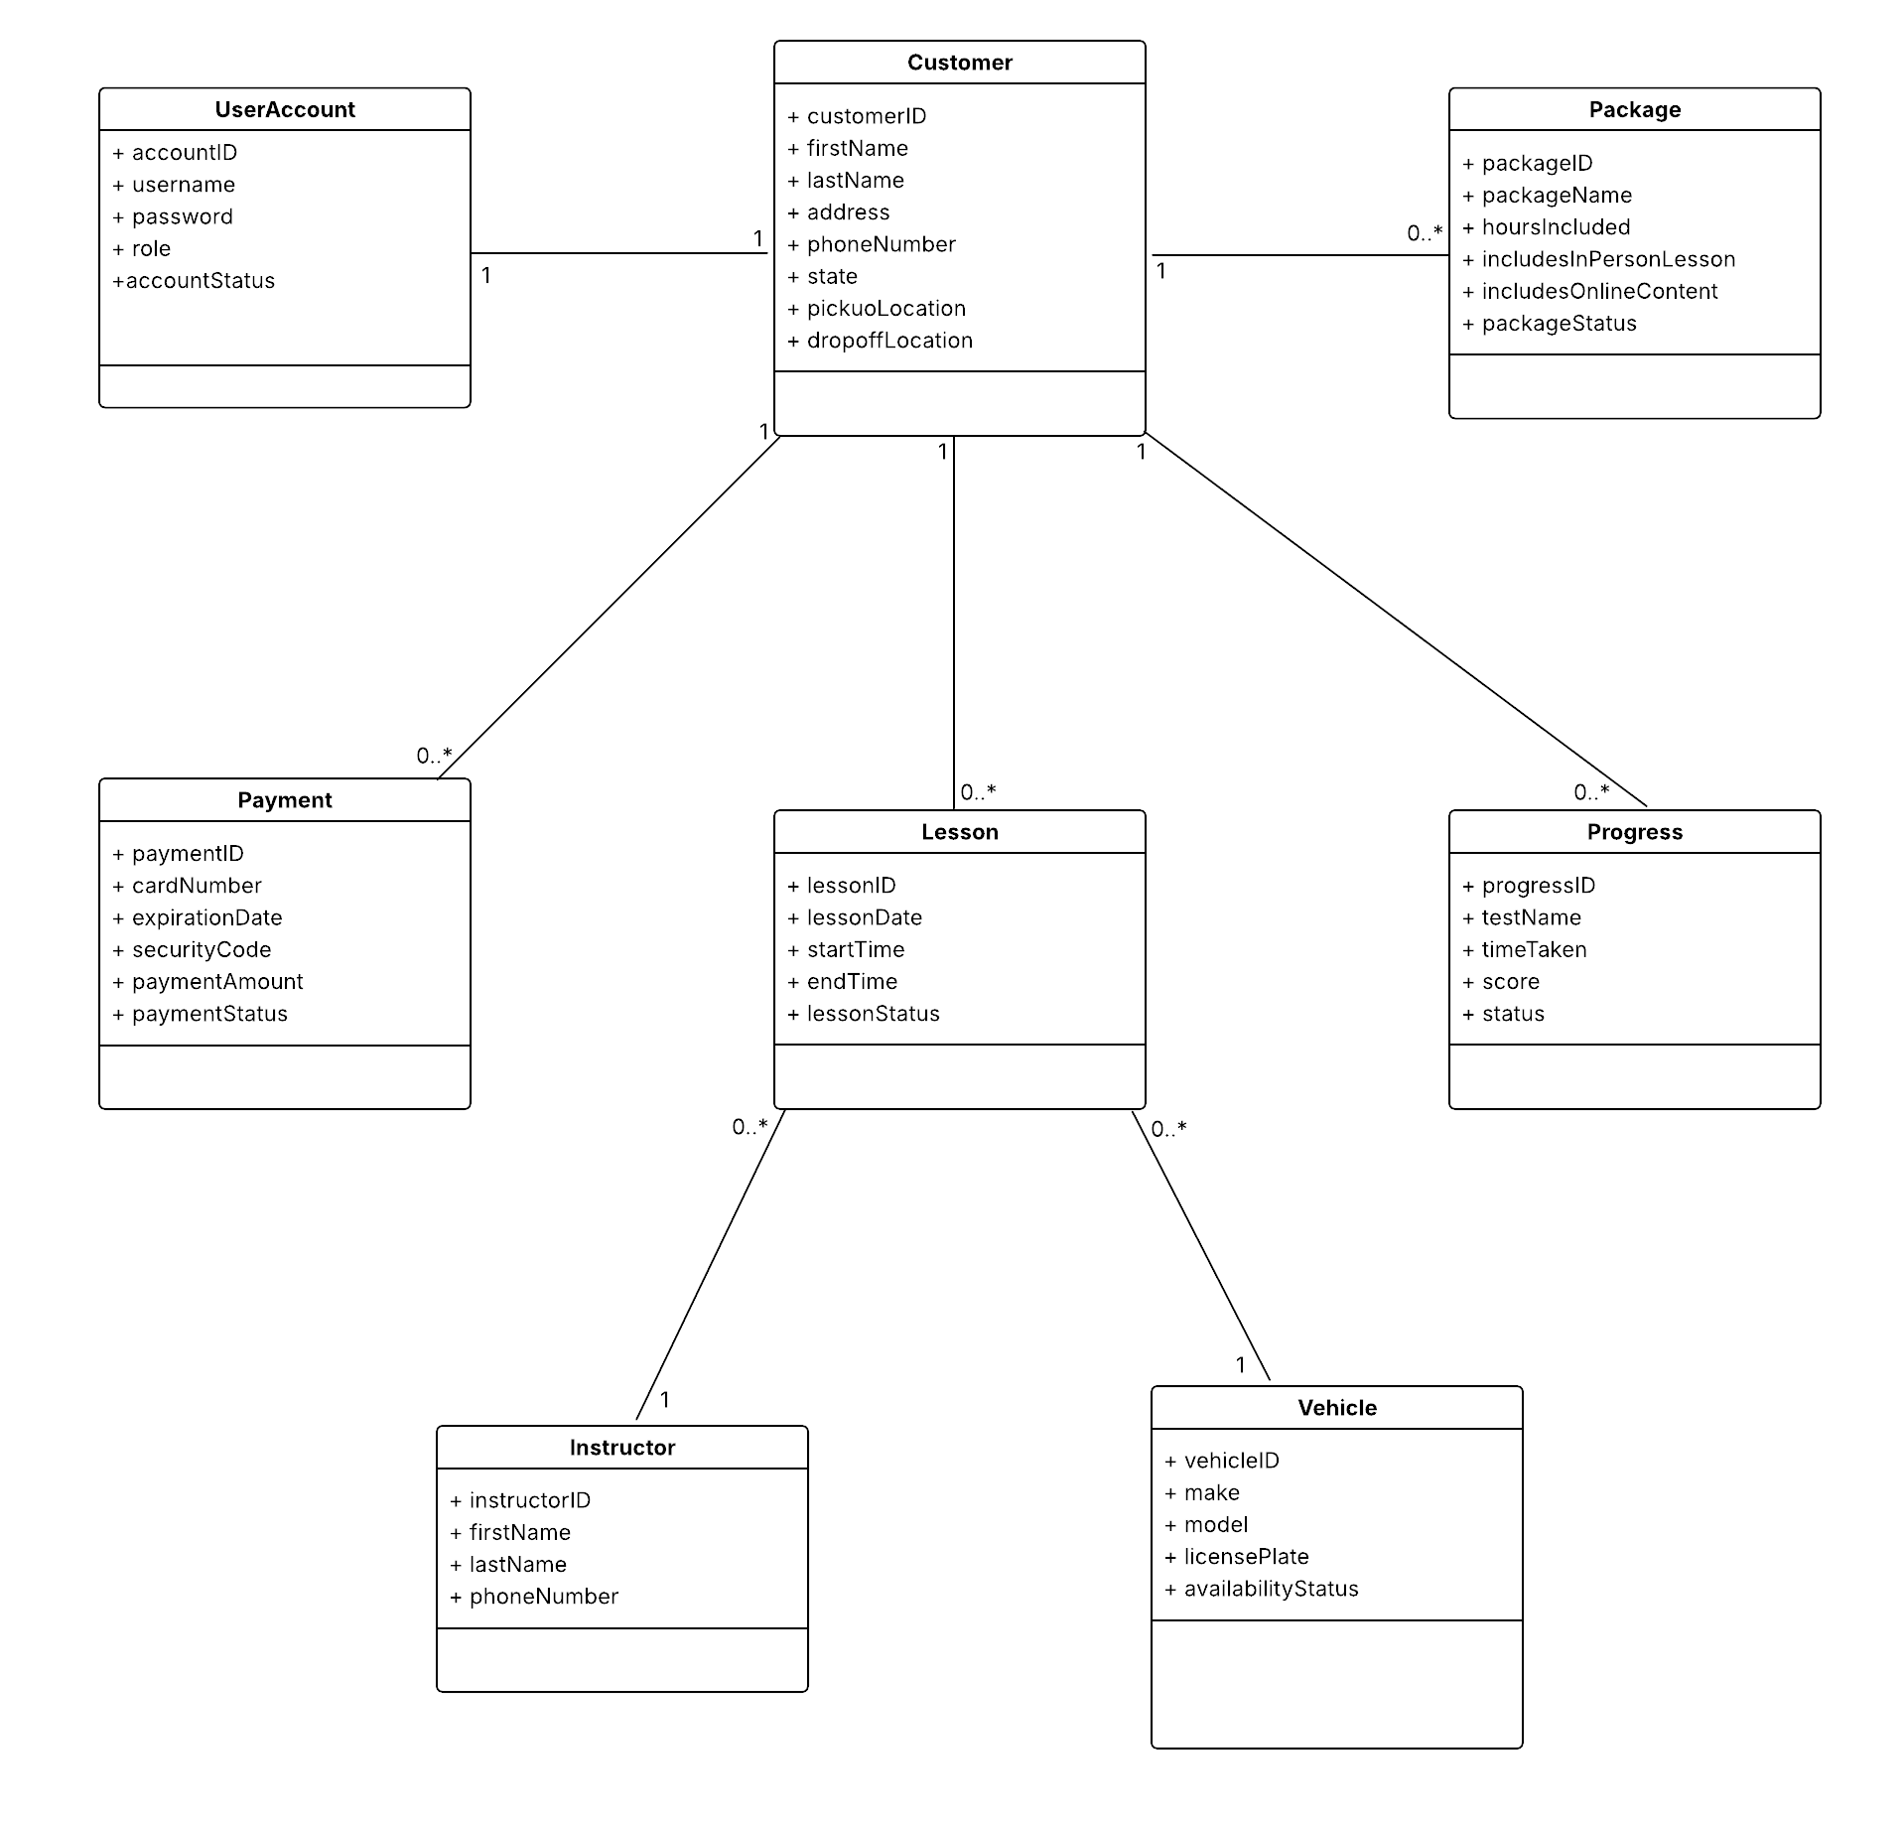

Technical Requirements

Hardware
The DriverPass system requires hardware that supports both customer access and internal business operations. Customers must be able to access the system using personal devices such as desktop computers, laptops, tablets, or mobile devices, since the client stated that the system should be accessible online from multiple locations (Southern New Hampshire University [SNHU], n.d.).
Administrative staff, including the secretary and the Information Technology (IT) officer, will require desktop or laptop computers to manage customer records, schedule driving lessons, assign instructors and vehicles, and maintain system data (SNHU, n.d.).
The system must also support input and processing of customer registration data, including personal information and payment details such as name, address, phone number, state, credit card number, expiration date, security code, pickup location, and drop off location, all of which were identified by the client as required inputs during the registration process (SNHU, n.d.).
From a systems design perspective, hardware must support user interaction, data input, and overall system performance to ensure that both customer and administrative tasks can be completed efficiently and reliably (Valacich & George, 2024).

Software
The DriverPass system requires software that supports a web-based application, as the client specifically requested a system that runs online and is preferably hosted through the cloud (SNHU, n.d.).
The software must support core system functions including user registration, log in, password reset, package selection, appointment scheduling, appointment modification, cancellation, lesson assignment, payment processing, online practice tests, and progress tracking. These features were directly described by the client as necessary to support both customer learning and business operations (SNHU, n.d.).
A database management system is required to store and manage system data such as customer records, user account information, lesson schedules, instructor assignments, vehicle usage, payment information, and test results. This requirement is supported by the client’s need to track reservations, identify which customer is assigned to a specific instructor, time, and vehicle, and maintain accurate records of customer progress and activity history (SNHU, n.d.).
The software must also support role-based access control. Different users require different levels of access. For example, the IT officer must be able to reset passwords and block accounts, the secretary must manage scheduling and customer records, and the system owner must generate reports and review system activity. This reflects the client’s requirement for multiple user roles with different permissions (SNHU, n.d.).
From a systems analysis and design perspective, software must support both business processes and data management to ensure system functionality, data integrity, and reliable performance (Valacich & George, 2024).

Tools
The development of the DriverPass system requires tools that support system planning, modeling, and communication. Modeling tools such as Lucidchart are used to create Unified Modeling Language (UML) diagrams, including use case, activity, sequence, and class diagrams. These diagrams are required to represent system behavior and structure and help translate business requirements into technical design.
These tools are important because they allow developers and stakeholders to clearly understand how the system is expected to function before it is built. This supports accurate system planning and reduces the likelihood of design errors during development (Valacich & George, 2024).
The project also requires tools for documentation and presentation. A word processing tool is needed to organize and present the system design document, while presentation software is required to communicate the system design to the client in a clear and understandable way. This is especially important because the client presentation must explain the system in nontechnical terms.
During system implementation, additional tools such as integrated development environments (IDEs) and database management tools will be required to build, test, and maintain the system. While these tools are not directly visible to the client, they are necessary to support the development and long-term operation of the system (Valacich & George, 2024).

Infrastructure
The DriverPass system requires a cloud-based infrastructure because the client stated that the system should run off the web and that the company does not want to manage backup and security internally (SNHU, n.d.).
This infrastructure must support reliable online access for multiple users. Customers must be able to register, schedule lessons, take practice tests, and view their progress, while staff must manage appointments, assign instructors and vehicles, and maintain system records. Because these activities can occur at the same time, the infrastructure must support multi-user access without performance issues or data inconsistencies (SNHU, n.d.).
The infrastructure must also support secure data storage and controlled system access. The system collects sensitive customer information, including personal details and payment data, and must ensure that this information is protected. In addition, the client emphasized that different employees have different roles and permissions, so the infrastructure must support authentication, authorization, and account management to enforce access control (SNHU, n.d.).
Finally, the infrastructure must support integration with the Department of Motor Vehicles (DMV). The client stated that the system must receive updates related to rules, policies, and test materials. This ensures that training content and practice tests remain current, which is essential for helping customers prepare effectively for their driving exams (SNHU, n.d.).
From a systems design perspective, infrastructure must support accessibility, scalability, and security to ensure that the system continues to meet user and business needs over time (Valacich & George, 2024).

References

Southern New Hampshire University. (n.d.). DriverPass interview transcript [Course material].

Valacich, J. S., & George, J. F. (2024). Modern Systems Analysis and Design (10th ed.). Pearson Education (US). https://bookshelf.vitalsource.com/books/9780138180294

